
DEPARTMENT OF COMPUTER SCIENCE AND ENGINEERING
CSA06 Design and Analysis of Algorithms
ASSIGNMENT
Assignment 1 - CO1
Name: Lekkala Vishnu Vardhan Reddy Register No.: 192372138
CO1 Coverage: Algorithm fundamentals, efficiency analysis, asymptotic analysis, mathematical analysis, recurrence analysis, Master Theorem, substitution, etc.
Course Outcome: CO1 – Determine algorithm efficiency using asymptotic notations and mathematical techniques including Master Theorem and substitution method.
Assignment Title: Design, Analyse and Validate an Efficient Search Strategy for a Large-Scale Student Record System (Total Marks - 50)
Duration: 1 week
Scenario — University Student Record Retrieval
A university maintains a large academic database containing student records, each identified by a unique Registration Number. Faculty and administrative staff frequently need to determine whether a particular student record exists and retrieve the corresponding information.
The database may contain: 1,000 → 10,000 → 100,000 → 1,000,000+ records
You are required to investigate, design and compare efficient algorithmic approaches for locating a given registration number as the database grows.
Your solution must remain practical for both small and very large datasets. Any preprocessing performed on the records must be included in your efficiency analysis.
Design Challenge:
The university now needs to process 50,000 search requests per hour on a database containing 1,000,000 student records. New student records are added only once per day.
Re-evaluate your original design and determine whether it should be retained, modified or redesigned.
TASK 1 – Design the Algorithm (5 Marks)
Design and propose at least three meaningfully different algorithmic strategies for locating a given registration number.
The three approaches must represent distinct algorithmic strategies. Iterative and recursive implementations of the same underlying algorithm will not be considered as two different approaches. Your proposed approaches must include:
- At least one iterative approach
- At least one recursive approach
- A clear explanation of the basic idea behind each approach
- Pseudocode or an appropriate flowchart for each approach
- A brief justification for selecting each approach for investigation
- Any preprocessing required by the approach, such as sorting or restructuring the data
You are expected to design and select the approaches independently. The appropriateness and diversity of the selected algorithmic strategies form part of the assessment.
Evidence Expected: Three meaningfully different algorithmic strategies, supported by pseudocode/flowcharts, identification of the design strategy, preprocessing requirements, and justification for selecting each approach.
ANSWER
Let n be the number of records and let the registration numbers be unique integers. I selected three strategies that rest on three different ideas: scan everything, discard half the data per step, and compute the location directly.
 | Approach 1 | Approach 2 | Approach 3
Name | Sequential (linear) search | Binary search on a sorted array | Hash table with separate chaining
Design strategy | Brute force | Decrease-and-conquer (decrease by half); preprocessing by merge sort (divide-and-conquer) | Transform-and-conquer / space-time trade-off (hashing)
Style | Iterative | Recursive | Iterative (bucket scan)
Preprocessing | None | Sort the records: O(n log n) | Build the table: O(n) time and O(n) extra space

Approach 1 – Sequential (linear) search [Brute force, iterative]
Basic idea: Examine the records one after another from the first to the last and compare each registration number with the key. Stop as soon as a match is found; if the end is reached, the record does not exist. Preprocessing: none – the records may be in any order.
ALGORITHM LinearSearch(A[0..n-1], key)
for i <- 0 to n-1 do
if A[i] = key then return i // basic operation: key comparison
return -1 // not found
Justification: It is the simplest correct solution and requires no organisation of the data, so it is the natural baseline. It is also the best choice when the number of searches is very small, because it has no set-up cost. Every other approach is judged against it.
Approach 2 – Binary search on a sorted array [Decrease-and-conquer, recursive]
Basic idea: Registration numbers are totally ordered. If the array is sorted, comparing the key with the middle element tells us which half can contain the key, so the other half is discarded. The same procedure is applied recursively to the remaining half until the key is found or the range becomes empty. Preprocessing: the records must first be sorted once. I use merge sort (divide-and-conquer): split in half, sort each half recursively, merge the two sorted halves.
ALGORITHM MergeSort(A[0..n-1]) // preprocessing
if n <= 1 then return A
mid <- floor(n/2)
L <- MergeSort(A[0..mid-1]); R <- MergeSort(A[mid..n-1])
return Merge(L, R) // repeatedly compare heads of L and R, copy the smaller

ALGORITHM BinarySearch(A, key, lo, hi) // A sorted; first call: lo=0, hi=n-1
if lo > hi then return -1 // empty range: not found
mid <- floor((lo + hi) / 2)
if A[mid] = key then return mid // basic operation: key comparison
else if key < A[mid] then return BinarySearch(A, key, lo, mid-1)
else return BinarySearch(A, key, mid+1, hi)
Justification: It exploits the ordering of the key, which linear search ignores. The cost of sorting is paid once and then shared by all later searches, so it is promising when searches are frequent. It also gives the required recursive approach, and a clean recurrence to analyse.
Approach 3 – Hash table with separate chaining [Transform-and-conquer / space–time trade-off, iterative]
Basic idea: Instead of comparing keys to find the location, compute the location from the key. A hash function h(k) = k mod m maps each registration number to one of m buckets (m = smallest prime ≥ n, so the load factor α = n/m ≈ 1). Colliding keys are kept in a small list (chain) in the same bucket. A search computes h(key) and scans only that bucket. Preprocessing: one pass over the records to build the table.
ALGORITHM BuildHashTable(A[0..n-1]) // preprocessing
m <- smallest prime >= n; T[0..m-1] <- empty lists
for i <- 0 to n-1 do append A[i] to T[ A[i] mod m ]
return T, m

ALGORITHM HashSearch(T, m, key)
for each x in T[ key mod m ] do
if x = key then return FOUND // basic operation: key comparison
return NOT FOUND
Justification: Searching by registration number is an exact-match lookup, so ordering is not needed. Hashing trades extra memory for expected constant search time and is the usual answer for read-heavy data. It is structurally different from both scanning and halving, so it satisfies the diversity requirement.
TASK 2 – Identify the Basic Operation (2 Marks)
For each of the proposed algorithms, identify the basic operation that predominantly determines its execution time.
Discuss:
- What the basic operation is
- Where it occurs in the algorithm
- Why it is appropriate to use this operation for efficiency analysis
- How the number of times it executes may change as the input size (n) increases
Do not simply name an operation. You are expected to relate the selected operation to the behaviour of the algorithm.
Evidence Expected: Correct identification and justification of the dominant/basic operation for each proposed algorithm.
ANSWER
In all three algorithms the dominant operation is the comparison of the search key with a stored registration number. It is the only operation that depends on the data, it sits at the innermost level of the algorithm (inside the loop or the recursive call), and everything else (index updates, computing mid, computing the hash) is done a fixed number of times per comparison.
Algorithm | Basic operation and where it occurs | Why it is appropriate | How its count changes with n
Linear search | A[i] = key, inside the for-loop body | Executed once per loop iteration; loop overhead is proportional to it. Whole running time is a constant multiple of this count. | Grows in direct proportion to n: up to n comparisons.
Binary search (recursive) | A[mid] = key, once in each recursive call | Each call does one comparison plus constant work (computing mid, passing bounds), so calls = comparisons. | The range halves each call, so the count grows only by 1 each time n doubles: about log2 n.
Merge sort (preprocessing) | L[i] ≤ R[j], inside the merge loop | Every element moved during a merge costs one comparison, so it counts the work of sorting. | Grows as n log2 n.
Hash table | x = key, while scanning the chain T[h(key)] | Computing h(key) is one constant-time step; the only variable work is walking the chain. | Depends on chain length (the load factor α = n/m), not directly on n; stays ≈ 1–1.5 when α ≈ 1.
Hash table build (preprocessing) | Insertion of a key into its bucket | One constant-time insert per record. | Exactly n insertions.

TASK 3 – Derive the Time-Complexity Function Mathematically (6 Marks)
Derive the time-complexity function for each proposed approach using mathematical analysis.
Discuss:
- The input size (n)
- The number of times the basic operation executes
- How the operation count changes with (n)
- The mathematical expression representing the running time
- Any preprocessing cost involved
- The overall cost when preprocessing and searching are considered together
You must show the mathematical reasoning leading to the complexity result. Merely stating that an algorithm is O(n), O(log n), etc., will not receive full credit.
Evidence Expected: A clear mathematical derivation of the time-complexity function for each approach, including relevant operation counts and preprocessing costs.
ANSWER
Input size: n = number of student records. Let C(n) be the number of key comparisons for one search, P(n) the preprocessing cost (also counted in comparisons or insertions), and q the number of searches performed. If one comparison with its surrounding constant work costs c time units, running time = c · C(n).
Approach 1 – Linear search
The loop runs for i = 0, 1, … and does one comparison per iteration. If the key is at position i (counting from 1) the cost is i comparisons; if it is absent the loop runs to the end.
- Successful search, key at position i: C = i. Best case (i = 1): C = 1. Worst case (i = n): C = n.
- Average successful search, assuming each of the n positions is equally likely (probability 1/n): C_avg = (1/n) · Σ i (i = 1 to n) = (1/n) · n(n+1)/2 = (n + 1)/2.
- Unsuccessful search: the whole array is scanned, C = n.
- If a fraction p of searches succeed: C_avg = p(n+1)/2 + (1 − p)n.
Running time T(n) = c · (n+1)/2 on average and c · n in the worst case, which is a linear function of n. Preprocessing: P(n) = 0. Overall for q searches: q · (n+1)/2 on average, i.e. Θ(q · n).
Approach 2 – Sorting + recursive binary search
Search cost. Each call performs one comparison and then recurses on at most ⌊n/2⌋ elements, giving C(n) = C(⌊n/2⌋) + 1 with C(1) = 1 (solved fully in Tasks 6 and 7). Unrolling by hand: after k comparisons at most ⌊n/2^k⌋ candidates remain. The search must stop when no candidate remains, i.e. when ⌊n/2^k⌋ = 0, which first happens at k = ⌊log2 n⌋ + 1. Therefore
C_worst(n) = ⌊log2 n⌋ + 1, and C_best = 1 (key at the first midpoint).
Numerically: n = 1,000 → 10; 10,000 → 14; 100,000 → 17; 1,000,000 → 20 comparisons. For the average successful search take n = 2^k − 1. One element is found at level 1 (1 comparison), two at level 2, four at level 3, …, 2^(k−1) at level k, so C_avg = Σ i·2^(i−1) / n = ((k − 1)·2^k + 1) / (2^k − 1) ≈ k − 1 ≈ log2 n − 1.
Preprocessing (merge sort). Merging two sorted lists of total length n needs at most n − 1 comparisons, so M(n) = 2M(n/2) + (n − 1), M(1) = 0. For n = 2^k, expanding gives M(n) = n·log2 n − n + 1 (check: k = 1 gives 2·1 − 2 + 1 = 1 ✓). The best case is about (n/2)·log2 n. For n = 1,000,000 the worst case is 1,000,000 × 19.93 − 1,000,000 + 1 ≈ 18.9 million comparisons; the measured count was 18,674,829 (Task 9), which lies inside the predicted range.
Overall cost for q searches: T_total(n, q) = (n·log2 n − n + 1) + q(⌊log2 n⌋ + 1) = Θ(n log n + q log n). Compared with linear search, which needs q·n/2 on average, sorting pays off once q·(n/2 − log2 n) > n·log2 n − n, i.e. after roughly q > 38 searches for n = 10^6 (counted in comparisons). Measured in real time the break-even point is about 180 searches (Task 10), because a comparison inside the sort and a recursive call cost more than a loop comparison.
Approach 3 – Hash table with chaining
Preprocessing. Building the table performs one constant-time insertion per record: B(n) = c·n, i.e. Θ(n) time, plus Θ(m) = Θ(n) extra space for the m ≈ n buckets.
Search cost. Computing h(key) = key mod m is one constant-time step. Assume simple uniform hashing: every key is equally likely to land in any of the m buckets, so the load factor is α = n/m ≈ 1.
- Unsuccessful search: the whole chain is scanned; expected chain length = n/m = α, so C_miss = α ≈ 1.
- Successful search: if the sought key was the i-th one inserted, then the keys ahead of it in its chain are the earlier i − 1 keys that fell into the same bucket, expected (i − 1)/m of them. Averaging over i = 1…n: C_hit = 1 + (1/n)·Σ (i − 1)/m = 1 + (n − 1)/(2m) ≈ 1 + α/2 = 1.5.
- Best case: key is first in its bucket, C = 1. Worst case: all n keys collide in one bucket, C = n.
So T_search = c₁ + c₂(1 + α/2) = Θ(1 + α), which is Θ(1) when α is bounded by a constant. Overall for q searches: Θ(n + q) (expected).
 | Preprocessing | One search (average) | One search (worst) | Total for q searches
Linear search | 0 | (n + 1)/2 | n | Θ(q · n)
Sort + binary search | n log2 n − n + 1 | log2 n − 1 | ⌊log2 n⌋ + 1 | Θ(n log n + q log n)
Hash table | Θ(n) | 1 + α/2 ≈ 1.5 | n (all keys collide) | Θ(n + q) expected

TASK 4 – Analyse Best, Average and Worst-Case Behaviour (4 Marks)
Analyse the performance of each algorithm under different input conditions.
Discuss, wherever applicable:
- What input condition produces the best case
- What input condition produces the average case
- What input condition produces the worst case
- How the number of operations changes in each case
- Why these differences occur
Do not simply provide a table containing complexity values. You are expected to explain the conditions that lead to each case.
Evidence Expected: A justified best-, average- and worst-case analysis for the proposed approaches, supported by appropriate mathematical reasoning.
ANSWER
Linear search
- Best case – 1 comparison: the requested registration number is the very first record. The loop exits in its first iteration, so the cost does not depend on n at all (Ω(1)).
- Average case – (n + 1)/2 comparisons: the key is equally likely to be anywhere, so on average half the list is scanned before the match. If many requested numbers do not exist, the average rises towards n.
- Worst case – n comparisons: the key is the last record, or is absent. Absent keys are the more important worst case because the algorithm cannot stop early; it must rule out every record. This happens because the data carries no structure that lets the algorithm skip any record.
Binary search (on the sorted array)
- Best case – 1 comparison: the key is exactly at the first midpoint, so the first call returns immediately.
- Average case – about log2 n − 1 comparisons: half of all records can only be reached at the deepest level of the implicit search tree, a quarter one level above it, and so on, so the typical successful search ends about one level before the last.
- Worst case – ⌊log2 n⌋ + 1 comparisons: the key lies at the deepest level of the tree, or is absent, so the range must be halved until it is empty. Because the range shrinks by half whatever the key is, the worst case is never far above the average – it is only about one comparison more.
- The merge sort used in preprocessing takes between (n/2)·log2 n comparisons (when one run is always exhausted early, e.g. already sorted input) and n·log2 n − n + 1 (when the two runs interleave perfectly). The depth of the recursion is log2 n in every case, so the difference is only in how many comparisons each merge needs.
Hash table
- Best case – 1 comparison (0 for an absent key whose bucket is empty): the key is first in its bucket.
- Average case – about 1.5 comparisons for a present key and α ≈ 1 for an absent key: keys are spread evenly, so the chains are short, with mean length α.
- Worst case – n comparisons: every key hashes to the same bucket, so the table degenerates into one long list. This can only happen if the hash function matches badly with the key pattern. The observed longest chain in the experiment was only 5, 6, 7 and 8 for n = 1,000 … 1,000,000, which shows that the mod-prime hash spreads the keys well in practice.
Measured evidence (Task 9 data). Best-case and worst-case comparisons observed in the experiments:
n | Linear: best / worst | Binary: best / worst observed | Binary: theoretical worst | Hash: best / worst (longest chain)
1,000 | 1 / 1,000 | 1 / 10 | 10 | 1 / 5
10,000 | 1 / 10,000 | 1 / 14 | 14 | 1 / 6
100,000 | 1 / 100,000 | 1 / 17 | 17 | 1 / 7
1,000,000 | 1 / 1,000,000 | 1 / 20 | 20 | 1 / 8

TASK 5 – Perform Asymptotic Analysis (3 Marks)
Express and compare the growth behaviour of your proposed algorithms using appropriate asymptotic notation.
Discuss:
- Appropriate use of O, Ω and/or Θ, wherever relevant
- How each algorithm behaves as n becomes very large
- How the growth rates of the proposed approaches differ
- What the growth behaviour means when the dataset increases from 1,000 to 1,000,000+ records
You are expected to interpret the asymptotic behaviour in the context of the given application, rather than merely state the notation.
Evidence Expected: Correct asymptotic representation and a meaningful comparison of the growth behaviour of the proposed approaches.
ANSWER
Algorithm | Best case | Average case | Worst case | Preprocessing | Overall (q searches)
Linear search | Ω(1) | Θ(n) | O(n) – tight, Θ(n) | none | Θ(q n)
Sort + binary search | Ω(1) | Θ(log n) | Θ(log n) | Θ(n log n) | Θ(n log n + q log n)
Hash table | Ω(1) | Θ(1) expected | O(n) | Θ(n) | Θ(n + q) expected

Notation used. Θ is used where the upper and lower bounds coincide (the average-case cost of linear search is both O(n) and Ω(n), so Θ(n)). O is used for upper bounds that need not be reached (hash-table worst case O(n), reached only when all keys collide). Ω(1) states the best case, which is constant for all three algorithms and therefore tells us very little – the average and worst cases are what matter for a university system.
Behaviour for very large n. Linear search grows proportionally with n: ten times more records means ten times more work. Binary search is logarithmic, so ten times more records adds only about 3.3 comparisons (log2 10). The hash table is constant: the work depends on the load factor, not on how many records exist. The ordering of growth rates is therefore 1 ≺ log n ≺ n ≺ n log n. The preprocessing terms follow the same order: Θ(n) for the hash table and Θ(n log n) for sorting.
Meaning for 1,000 → 1,000,000 records (a thousand-fold increase). The measured average comparisons for a successful search are:
n | 1,000 | 10,000 | 100,000 | 1,000,000 | Growth factor 1K → 1M
Linear (avg) | 500 | 4,790 | 44,013 | 597,509 | ≈ 1,194× (expected ≈ 1,000×)
Binary (avg) | 8.98 | 12.36 | 15.68 | 18.97 | ≈ 2.1×
Hash (avg) | 1.51 | 1.49 | 1.50 | 1.50 | ≈ 1.0× (flat)

For the university this means: a linear scan which is acceptable for a department database (≈ 500 comparisons) becomes unreasonable for the whole university (≈ 500,000 comparisons per lookup). Binary search needs only about 10 more comparisons for a thousand-fold larger database, so it remains practical as the database grows, provided the sorting cost is paid once. Hashing gives the same cost at every size, but needs extra memory proportional to n.
TASK 6 – Formulate the Recurrence Relation (3 Marks)
For the recursive approach, formulate a recurrence relation directly from the behaviour of the algorithm.
Clearly identify:
- The input size of the original problem
- The size of the recursive subproblem
- The number of recursive calls
- The work performed outside the recursive call
- The base case
- How these components lead to the recurrence relation
The recurrence must be derived from your algorithm, rather than simply writing a known recurrence formula.
Evidence Expected: A correctly formulated recurrence relation with clear identification of its components and base case.
ANSWER
The recursive approach is BinarySearch(A, key, lo, hi) from Task 1. I read each component of the recurrence directly from its pseudocode.
Component | Reading from the algorithm
Input size of the original problem | n = hi − lo + 1, the number of records still under consideration (initially all n records).
Size of the recursive subproblem | After comparing with A[mid], the search continues either on A[lo..mid−1] (mid − lo elements) or on A[mid+1..hi] (hi − mid elements). With mid = ⌊(lo + hi)/2⌋ each part has at most ⌊n/2⌋ elements. For the worst-case analysis we take ⌊n/2⌋.
Number of recursive calls | Exactly one: the if / else-if / else chain selects only one of the two halves. The other half is never searched, because the sorted order proves the key cannot be there. (a = 1)
Work outside the recursive call | Computing mid, one comparison with A[mid] (plus possibly one more to choose a side, which we count as the same single key comparison), and passing new bounds: constant work, counted as 1 comparison.
Base case | lo > hi, i.e. n = 0: the range is empty, return −1 with no comparison, so T(0) = 0. Equivalently T(1) = 1: a one-element range costs one comparison and then reaches the empty base case.

Combining the pieces: cost of the call = (work outside the call) + (cost of the one recursive call on the half-size problem):
T(n) = T(⌊n/2⌋) + 1 for n ≥ 1, T(0) = 0 (hence T(1) = 1)
In the form used for the Master Theorem, T(n) = a·T(n/b) + f(n) with a = 1, b = 2 and f(n) = Θ(1).
Preprocessing recurrence (merge sort). From the MergeSort pseudocode: two recursive calls (a = 2) on halves of size ⌊n/2⌋ and ⌈n/2⌉ (b = 2); the merge outside the calls does at most n − 1 comparisons, so M(n) = 2M(n/2) + (n − 1), base case M(1) = 0.
TASK 7 – Solve the Recurrence Relation (4 Marks)
Solve the recurrence relation obtained in Task 6 using an appropriate analytical method.
You may use:
- Substitution method
- Iteration method
- Master Theorem
- Another appropriate analytical technique
Discuss:
- Why the selected method is applicable
- The steps involved in solving the recurrence
- The resulting complexity
- What the result indicates about the behaviour of the recursive algorithm as (n) increases
You are expected to show the analytical process, rather than provide only the final complexity.
Evidence Expected: A complete recurrence solution using an appropriate method, together with justification of the method and interpretation of the result.
ANSWER
I solve T(n) = T(n/2) + 1 with three methods: the iteration method to derive the solution, the substitution method to prove it, and the Master Theorem as a cross-check.
Method 1 – Iteration (backward substitution)
Applicable because the recurrence reduces the size by a constant factor each time, and the pattern of terms is visible after expanding it a few times. Take n = 2^k (the general case differs by at most one comparison).
T(n) = T(n/2) + 1
= [T(n/4) + 1] + 1 = T(n/4) + 2
= [T(n/8) + 1] + 2 = T(n/8) + 3
...
= T(n/2^i) + i (pattern after i expansions)
Stop when n/2^i = 1, i.e. i = log2 n:
T(n) = T(1) + log2 n = 1 + log2 n
So T(n) = log2 n + 1 for powers of two, and for general n T(n) = ⌊log2 n⌋ + 1.
Method 2 – Substitution (proof by induction)
Guess from the iteration above: T(n) ≤ log2 n + 1 for all n ≥ 1.
- Base case: n = 1: T(1) = 1 ≤ log2 1 + 1 = 1 ✓.
- Inductive step: assume T(m) ≤ log2 m + 1 for all 1 ≤ m < n. Then T(n) = T(⌊n/2⌋) + 1 ≤ (log2 ⌊n/2⌋ + 1) + 1 ≤ (log2 (n/2) + 1) + 1 = (log2 n − 1) + 1 + 1 = log2 n + 1 ✓.
- Hence T(n) ≤ log2 n + 1 = O(log n). For the lower bound, each comparison can at best halve the candidates, so at least log2(n+1) comparisons are needed for the worst-case key: T(n) = Ω(log n). Together T(n) = Θ(log n).
Method 3 – Master Theorem (cross-check)
The Master Theorem applies to recurrences of the form T(n) = aT(n/b) + f(n) with a ≥ 1, b > 1. Here a = 1, b = 2, f(n) = 1 = Θ(1). Compute n^(log_b a) = n^(log2 1) = n^0 = 1. Since f(n) = Θ(n^(log_b a)) = Θ(1), we are in Case 2, giving T(n) = Θ(n^(log_b a) · log n) = Θ(log n), which agrees with the other two methods.
Merge sort (preprocessing). M(n) = 2M(n/2) + n: a = 2, b = 2, f(n) = n, n^(log2 2) = n. Again f(n) = Θ(n^(log_b a)), so Case 2 applies: M(n) = Θ(n log n). By iteration: M(n) = 2^i·M(n/2^i) + i·n; setting i = log2 n gives n·M(1) + n·log2 n = Θ(n log n).
Interpretation. The solution log2 n + 1 means that every doubling of the number of records adds exactly one extra comparison. Going from 1,000 to 1,000,000 records (a thousand-fold increase, about 10 doublings) increases the worst-case comparisons only from 10 to 20, which is the behaviour measured in the experiments (Task 9). The recursion depth is also only about 20, so the stack use of the recursive version is negligible; there is no risk of stack overflow even for hundreds of millions of records.
TASK 8 – Implement and Test the Algorithms (4 Marks)
Implement all the proposed algorithmic approaches and experimentally test their behaviour.
Use datasets of approximately: 1,000 → 10,000 → 100,000 → 1,000,000 records
Ensure that:
- All algorithms produce the correct result
- The same or equivalent datasets are used for comparison
- Testing conditions are kept reasonably consistent
- Appropriate test cases are included
- The implementation corresponds to the algorithms analysed in the previous tasks
The purpose of implementation is not merely to demonstrate working code, but to generate evidence for validating your theoretical analysis.
Evidence Expected: Working implementations of the proposed algorithms together with a clearly described and reproducible testing procedure.
ANSWER
All three algorithms are implemented in Python 3 in the single file experiment.py (submitted with this document). Each version counts comparisons so that the measured counts can be compared with the formulas in Tasks 3 and 4; a separate "plain" copy without counters is used for timing so that counting does not distort the timings.
Core implementation
def linear_search(a, key): # Approach 1 (iterative)
for i in range(len(a)):
if a[i] == key: return i
return -1

def merge_sort(a): # preprocessing for Approach 2
if len(a) <= 1: return a
mid = len(a) // 2
L, R = merge_sort(a[:mid]), merge_sort(a[mid:])
out, i, j = [], 0, 0
while i < len(L) and j < len(R):
if L[i] <= R[j]: out.append(L[i]); i += 1
else: out.append(R[j]); j += 1
return out + L[i:] + R[j:]

def binary_search(a, key, lo, hi): # Approach 2 (recursive)
if lo > hi: return -1
mid = (lo + hi) // 2
if a[mid] == key: return mid
if key < a[mid]: return binary_search(a, key, lo, mid - 1)
return binary_search(a, key, mid + 1, hi)

def build_table(keys): # preprocessing for Approach 3
m = next_prime(len(keys)); t = [None] * m
for k in keys:
h = k % m
if t[h] is None: t[h] = [k]
else: t[h].append(k)
return t, m

def hash_search(t, m, key): # Approach 3 (bucket scan)
b = t[key % m]
if b is None: return -1
for x in b:
if x == key: return 1
return -1
Testing procedure (reproducible)
- Datasets: for each n = 1,000; 10,000; 100,000; 1,000,000 a list of n unique 9-digit registration numbers is drawn at random (random seed 42), in unsorted order. All three algorithms receive the same list (the sorted copy and the hash table are built from it).
- Queries: 20,000 successful searches (keys drawn at random from the stored records) and 20,000 unsuccessful searches (random 9-digit numbers not in the database) for binary search and hashing. Linear search is slow at large n, so it uses fewer queries from the same query list: 2,000, 200, 20 and 20 for the four sizes.
- Measures per size: comparisons per search (average and maximum), time per search (microseconds, wall-clock using time.perf_counter), sorting time and comparisons, hash-table build time, load factor and longest chain.
- Consistency: one machine, one Python process, no other work in the loop; timings use the counter-free copies of the algorithms.
- Correctness check: for every size, 500 present and 500 absent keys are searched with all three algorithms, and the results are asserted to be identical (all assertions passed). Binary search results are also checked for returning the correct index (sorted[index] == key).
Edge-case tests (each run with all three algorithms – all three agreed with the expected result in every case):
Test case | Expected result | Linear / Binary / Hash
Key is the first stored record | found | all correct ✓
Key is the last stored record | found | all correct ✓
Key is the middle of sorted order | found | all correct ✓
Key smaller than every record | not found | all correct ✓
Key larger than every record | not found | all correct ✓
Key between two stored records | not found | all correct ✓
Database with a single record (present) | found | all correct ✓
Database with a single record (absent) | not found | all correct ✓
Two records, search the larger | found | all correct ✓
Records already sorted ascending | found | all correct ✓
Records sorted descending | found | all correct ✓

An empty database also returns "not found" for linear and binary search (hash table construction is skipped for an empty input).
TASK 9 – Record Experimental Performance (3 Marks)
Collect and present experimental performance data for each algorithm across the different input sizes.
Record appropriate measures such as:
- Execution time
- Number of comparisons
- Number of key operations
- Input size
- Other relevant performance measures, where justified
Present the results using appropriate:
- Tables
- Graphs
- Performance plots
Ensure that the presentation allows the different approaches to be easily compared.
Evidence Expected: Systematically collected experimental data presented clearly using appropriate tables and/or graphs.
ANSWER
Table 9.1 – Average key comparisons per search
n | Linear (found) | Linear (not found) | Binary (found) | Binary (not found) | Hash (found) | Hash (not found)
1,000 | 500 | 1,000 | 8.98 | 9.98 | 1.51 | 1.00
10,000 | 4,790 | 10,000 | 12.36 | 13.36 | 1.49 | 1.00
100,000 | 44,013 | 100,000 | 15.68 | 16.68 | 1.50 | 1.00
1,000,000 | 597,509 | 1,000,000 | 18.97 | 19.95 | 1.50 | 1.01

Table 9.2 – Average search time per query (microseconds, pure Python)
n | Linear (found) | Linear (not found) | Binary (found) | Binary (not found) | Hash (found) | Hash (not found)
1,000 | 20.4 | 41.9 | 2.04 | 2.20 | 0.31 | 0.29
10,000 | 161.8 | 326.1 | 2.08 | 2.25 | 0.26 | 0.18
100,000 | 1,407.6 | 3,247.1 | 3.22 | 4.16 | 0.76 | 0.61
1,000,000 | 22,695.1 | 35,682.9 | 4.97 | 5.24 | 0.92 | 0.73

Table 9.3 – Preprocessing cost
n | Merge sort comparisons | Merge sort time (s) | Hash build time (s) | Hash table size m | Load factor α | Longest chain
1,000 | 8,712 | 0.0026 | 0.0010 | 1,009 | 0.991 | 5
10,000 | 120,469 | 0.0236 | 0.0028 | 10,007 | 0.999 | 6
100,000 | 1,536,366 | 0.3358 | 0.0402 | 100,003 | 1.000 | 7
1,000,000 | 18,674,829 | 4.0813 | 0.9142 | 1,000,003 | 1.000 | 8

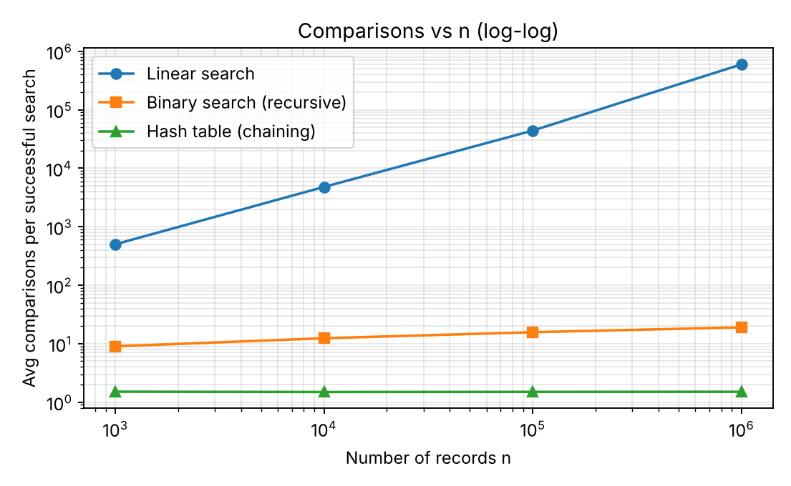
Figure 9.1 – Average comparisons per successful search (log-log scale)
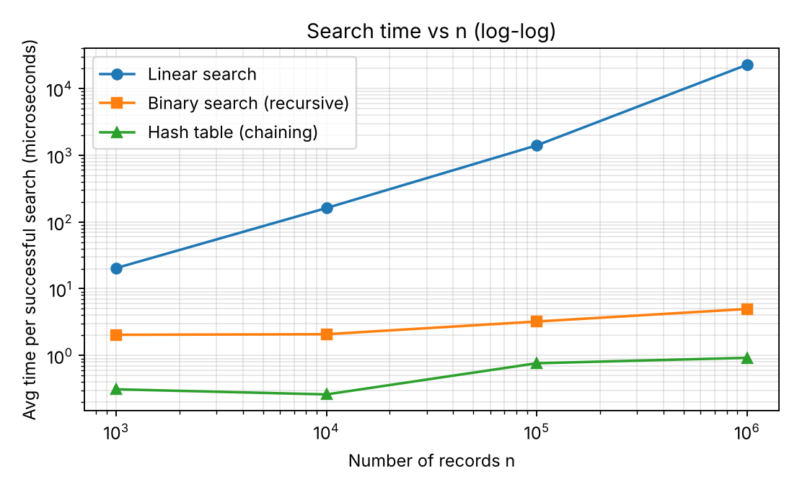
Figure 9.2 – Average time per successful search (log-log scale)
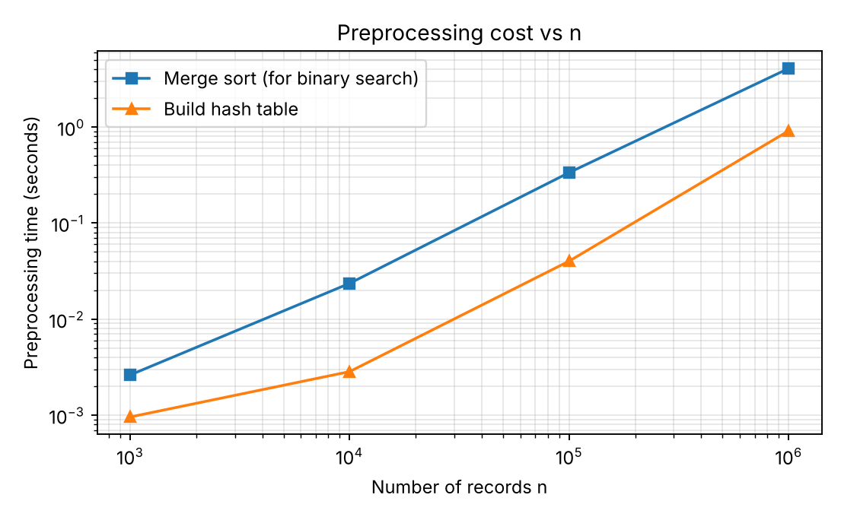
Figure 9.3 – Preprocessing time versus n (log-log scale)
Reading the plots: on a log-log scale a straight line of slope 1 indicates linear growth (linear search and, almost, the sort), a nearly flat line indicates constant growth (hash table), and a line that rises very slowly indicates logarithmic growth (binary search).
TASK 10 – Compare Theory with Experimental Behaviour (4 Marks)
Compare your theoretical analysis with your experimental results.
Discuss:
- Whether the observed growth agrees with the theoretical complexity
- Which algorithm scales better as (n) increases
- Any differences between theoretical prediction and actual execution
- Possible reasons for the differences
You are expected to interpret the results, rather than simply reproduce tables or graphs.
Evidence Expected: A reasoned comparison between theoretical and experimentally observed performance.
ANSWER
Do the observed counts agree with the derived formulas?
n | Linear: predicted (n+1)/2 | Linear: measured | Binary: predicted log2 n − 1 | Binary: measured | Hash: predicted 1 + α/2 | Hash: measured
1,000 | 501 | 500 | 8.97 | 8.98 | 1.50 | 1.51
10,000 | 5,001 | 4,790 | 12.29 | 12.36 | 1.50 | 1.49
100,000 | 50,001 | 44,013 | 15.61 | 15.68 | 1.50 | 1.50
1,000,000 | 500,001 | 597,509 | 18.93 | 18.97 | 1.50 | 1.50

- Binary search and hashing agree very closely with the theory: the measured binary comparisons are within 0.1 of log2 n − 1 and the maximum observed equals ⌊log2 n⌋ + 1 exactly (10, 14, 17, 20). The hash measurements match 1 + α/2 ≈ 1.5 for found keys and α ≈ 1 for missing keys at every size.
- Linear search follows (n+1)/2 only roughly: 4,790 vs 5,000 at n = 10,000, 44,013 vs 50,000 at n = 100,000 and 597,509 vs 500,000 at n = 1,000,000. This is sampling error, not a failure of the theory: at large n only 20 queries were used, and the mean position of 20 random keys has a standard deviation of about n/√(12·20) ≈ 0.065n. The deviations (−4%, −12%, +20% of the theoretical mean) are all within about 1.5 standard errors. Unsuccessful searches are not random at all and give exactly n comparisons (1,000; 10,000; 100,000; 1,000,000), as predicted.
- Merge sort: measured comparisons 18,674,829 for n = 10^6 lie between (n/2)log2 n ≈ 10.0 million and n·log2 n − n + 1 ≈ 18.9 million, close to the worst-case formula as expected for randomly ordered keys. Sorting time grows by a factor of 12.2 from 100,000 to 1,000,000; the theoretical n log n factor is 12.0.
Growth in running time
Linear-search time per query rose from 20.4 µs to 22,695 µs (≈ 1,113×) for a 1,000× larger database, in line with Θ(n). Binary search rose only from 2.04 µs to 4.97 µs (≈ 2.4×) – the logarithmic growth predicted. Hash search stayed below 1 µs at all sizes. Hashing scales best, binary search scales almost as well, and linear search does not scale.
Differences between theory and execution, and why
- Time grows slightly faster than the comparison count for binary search and hashing. Binary comparisons only rose ×2.1 but time rose ×2.4; for hashing the comparison count is flat (≈ 1.5) but time rose from 0.31 µs to 0.92 µs. The theory assumes that every memory access costs the same. In reality the 1,000,000-element list and its objects do not fit in the processor cache, so each probe at large n pays a cache-miss penalty, whereas at n = 1,000 everything stays in cache.
- Constants differ between algorithms. A linear-search comparison cost about 0.04 µs, but one recursive binary-search step cost about 0.26 µs because every step also makes a function call and computes mid. That is why the time-based break-even between linear and binary search (≈ 180 searches) is larger than the comparison-based estimate (≈ 38).
- Absolute values depend on the language. The numbers come from interpreted Python and would be much smaller in C, but ratios and growth rates are what the theory predicts. Very small timings (sub-microsecond) also contain timer and loop overhead, which explains the small non-monotonic wobble of the hash timings between 1,000 and 10,000 records.
- Random sampling (as explained above) causes the linear-search averages at large n to deviate from (n+1)/2.
TASK 11 – Recommend and Defend the Final Design (4 Marks)
Based on your mathematical analysis and experimental findings, recommend the most appropriate algorithmic solution for the university student-record system.
Discuss:
- Which approach you recommend
- Why it is more appropriate than the alternatives
- Its theoretical efficiency
- Its experimentally observed performance
- Any preprocessing cost involved
- Relevant trade-offs or limitations
- Whether the solution remains practical as the database grows
Your recommendation must be based on evidence obtained from your own analysis and experimentation. Simply identifying the algorithm with the lowest Big-O complexity is not sufficient.
Evidence Expected: A technically justified final design recommendation supported by both mathematical analysis and experimental evidence.
ANSWER
Recommendation: keep the records in a sorted array and search them with binary search (Approach 2). Hashing is the fastest, so it is the runner-up and is brought in as an add-on index in Task 12; linear search is rejected.
 | Linear search | Sort + binary search | Hash table
Search comparisons at n = 1,000,000 (avg / worst) | ≈ 597,509 / 1,000,000 | 18.97 / 20 (guaranteed) | 1.50 / 8 observed (n worst-case possible)
Search time at n = 1,000,000 | 22,695 µs | 4.97 µs | 0.92 µs
Preprocessing at n = 1,000,000 | none | 4.08 s (Θ(n log n)) | 0.91 s (Θ(n))
Extra memory | none | none (sort in place or keep one sorted copy) | Θ(n) buckets and chains
Supports range / ordered queries (e.g. all students of a batch) | no (full scan) | yes – two binary searches | no
Worst-case guarantee | n | log2 n + 1 | n (only if all keys collide)

Why binary search rather than the alternatives. Linear search is the only one with no preprocessing, but a lookup at 10^6 records costs about 22,700 µs, 4,500 times more than binary search, and the sort cost is recovered after about 180 searches. Hashing is faster still per query and cheaper to build (0.91 s vs 4.08 s), but it depends on a probabilistic assumption (uniform spreading of keys), needs Θ(n) extra memory, and cannot answer ordered questions such as "all registration numbers in a given range" (for example one batch of students), which a university system certainly needs. Binary search gives a hard worst-case bound of 20 comparisons at one million records and the same sorted array also supports range retrieval. I therefore did not pick the approach merely because it has the lowest Big-O: hashing has the lowest expected cost, but the guarantee and the extra capabilities of the sorted array were the deciding factors given that its measured time is already only about 5 µs.
Preprocessing and its trade-offs. Sorting costs Θ(n log n): 4.08 s at 10^6 records in this Python implementation. It is a one-off cost, and amortised over the later searches it is small. The limitation is updates: inserting a new record into a sorted array costs Θ(n) (shifting), so the array should be updated in batches (merging a sorted batch of k new records in Θ(n + k log k)) and not by individual inserts. Practical as the database grows? Yes: going from 10^3 to 10^6 records added about 10 comparisons per search (8.98 → 18.97) and about 3 µs per search, and sorting follows n log n (12× for a 10× larger database).
DAY-4 DESIGN CHALLENGE
TASK 12 – Re-evaluate and Adapt the Design (8 Marks)
Changed Requirement
The university now needs to process 50,000 search requests per hour on a database containing 1,000,000 student records. However, new student records are added only once per day. Re-evaluate your original design in response to these changed operating conditions.
You may: RETAIN → MODIFY → or REDESIGN your original solution.
A. Impact Analysis – 2 Marks
Discuss:
- What has changed from the original problem
- Which original assumptions are affected
- Why the frequency of searches is now important
- Why the relatively low frequency of record updates may influence the design
Evidence Expected: A clear analysis of how the changed requirements affect the original algorithmic design.
ANSWER
- What changed: the original problem asked for the best way to find one record as the database grows. Now the workload is fixed and very specific: n = 1,000,000 records, q = 50,000 searches/hour (≈ 13.9 per second; ≈ 1.2 million per day) and one batch of insertions per day.
- Assumptions affected: (1) the original analysis treated a single search as the unit of cost, so the preprocessing cost looked like an overhead; with 1.2 million searches a day it is a fixed cost shared by every search. (2) A general-purpose design had to tolerate arbitrary inserts, deletes and mixed workloads; now the data is effectively static for 24 hours at a time.
- Why search frequency matters: total cost = preprocessing + q × per-search cost. At q = 1.2 million per day, even a small saving per search is multiplied by a very large q. Linear search at about 22.7–35.7 ms per search would consume 7.6–11.9 CPU hours per day; any per-search cost measured in microseconds changes the picture entirely.
- Why rare updates matter: structures that are expensive to build but cheap to query (sorted array, hash table) become attractive precisely when they rarely need rebuilding. A sort or hash build performed once a day is spread over 1.2 million searches (4.08 s ÷ 1.2 M ≈ 3.4 µs per search for sorting, 0.91 s ÷ 1.2 M ≈ 0.8 µs for hashing). It also means the usual weak spots – the Θ(n) cost of inserting into a sorted array, and the cost of resizing a hash table – are exercised only once a day and can be handled in an overnight batch job. And readers never see a half-updated structure if the new version is built aside and swapped in.
B. Evaluation of the Original Design – 2 Marks
Evaluate whether your original recommended solution remains appropriate.
Discuss:
- Its expected behaviour under 50,000 searches per hour
- Whether its preprocessing cost is acceptable under the new conditions
- Whether another approach could provide better overall performance
Evidence Expected: A technically supported evaluation of the suitability of the original design under the new operating conditions.
ANSWER
The table uses the measured n = 1,000,000 figures and compares the total daily cost (preprocessing once + 1.2 million searches):
 | Per search | CPU per hour (50,000 searches) | Preprocessing (once a day) | Total per day (1.2 M searches)
Linear search | 22.7–35.7 ms | 1,135–1,784 s (32–50% of one core) | none | 7.6–11.9 hours
Sort + binary search (original) | 4.97–5.24 µs | 0.25 s | 4.08 s full sort | ≈ 10.0 s
Hash table | 0.73–0.92 µs | 0.05 s | 0.91 s build | ≈ 2.0 s

- Expected behaviour of the original design: 50,000 searches per hour is only one search every 72 ms on average, while one binary search takes about 5 µs and at most 20 comparisons. The load would use about 0.25 s of CPU per hour, i.e. less than 0.01% of one core. The design handles the load with an enormous margin.
- Preprocessing cost: a full sort of 4.08 s once a day is trivial compared with the 24 hours available, and per search it adds ≈ 3.4 µs. Re-sorting all million records every night just to add a few new ones is nevertheless wasteful: it repeats Θ(n log n) work to change a small fraction of the data, and I measured that a merge of the sorted old array with a sorted batch of 1,000 new records takes 0.50 s, 8× faster than a re-sort.
- Could another approach give better overall performance? Yes, marginally. The hash table has a lower cost per search (≈ 0.9 µs vs 5.0 µs, i.e. 5× less) and a cheaper build (0.91 s vs 4.08 s). Linear search is clearly not acceptable: 7.6–11.9 CPU-hours per day against about 10 seconds for binary search. The honest conclusion is that the original design remains correct and fast enough; what the new conditions change is that an index of constant expected cost is now worth adding, and the update procedure should be made incremental.
C. Adaptation or Redesign – 2 Marks
Decide whether to:
Retain, modify or redesign the original solution.
If you modify or redesign it:
- Describe the revised algorithmic strategy
- Explain what has changed
- Determine the effect on computational complexity
If you retain the original solution, provide sufficient technical justification for why no redesign is necessary.
Evidence Expected: An appropriate design response to the changed requirement, with clear algorithmic reasoning.
ANSWER
Decision: MODIFY. The sorted array and binary search are retained as the master structure (they give the guarantee and range queries); two modifications make the system fit the new workload.
- Modification 1 – nightly batch merge instead of a full re-sort. During the day new records are collected in a small buffer. Once a day the buffer (k records) is sorted in Θ(k log k) and merged with the sorted master array in a single linear pass, Θ(n + k). Measured for k = 1,000 and n = 1,000,000: 0.50 s, versus 4.08 s for sorting everything again. The result is built as a new array and swapped in atomically, so searches during the update always see a consistent snapshot.
- Modification 2 – a hash index for exact-match lookups. After the merge, the registration numbers are inserted into a hash table with chaining (h(k) = k mod m, m prime ≈ n). Exact-match searches, which are the overwhelmingly common request, consult the hash table first (expected Θ(1)); ordered or range requests, and a verification fall-back, use the sorted array. Adding the day's k new keys to the table is Θ(k) (measured 0.00045 s for 1,000 keys); the table is rebuilt in Θ(n) (0.91 s) only when the load factor has grown too much.
 | Original design | Revised design
Exact-match search | Θ(log n) worst case, ≈ 19 comparisons, 5.0 µs | Θ(1) expected, ≈ 1.5 comparisons, 0.9 µs; Θ(log n) fall-back
Range / ordered query | Θ(log n + r) | Θ(log n + r) (unchanged, uses the sorted array)
Daily update (k new records) | Θ(n log n) re-sort | Θ(n + k log k) merge + Θ(k) index insertions
Extra space | none | Θ(n) for the hash index
Daily total, 1.2 M searches | ≈ 10 s | ≈ 0.5 s merge + 0.0005 s index insert + 1.1 s of searching ≈ 1.6 s

The overall complexity for one day becomes Θ(n + k log k + q) instead of Θ(n log n + q log n): the logarithmic factors have been removed from both the update and the search. The cost is Θ(n) extra memory (about one list reference per record, in the order of tens of MB for a million records) and the need to keep the two structures in step.
D. Evidence-Based Defence – 2 Marks
Defend your final design decision using evidence.
Use:
- Mathematical complexity analysis
- Experimental results, where appropriate
- Search frequency
- Preprocessing cost
- Dataset size
- Relevant computational trade-offs
Your final decision must follow logically from your analysis.
Evidence Expected: A well-supported final design decision integrating theoretical analysis, experimental evidence and the changed system constraints.
ANSWER
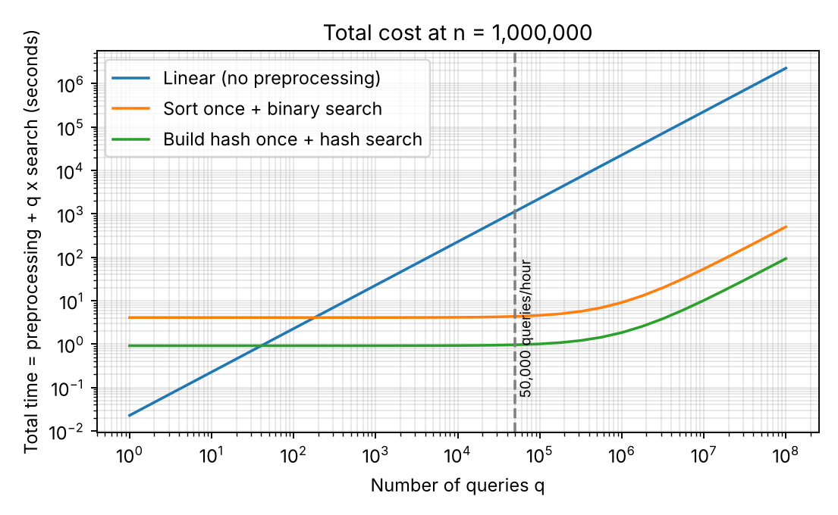
Figure 12.1 – Total time (preprocessing + searches) at n = 1,000,000 as the number of searches grows
- Search frequency and dataset size → reject linear search. Complexity Θ(q·n) gives about 2.5 × 10^10 comparisons per hour on average at q = 50,000 and n = 10^6, measured as 19–30 CPU-minutes per hour and 7.6–11.9 CPU-hours per day, against about 10 seconds a day for the sorted array. Figure 12.1 shows that the linear curve overtakes both preprocessed approaches after only about 40 searches (hash) and 180 searches (sorted array), far below the 1.2 million searches per day the system must serve.
- Preprocessing cost and update frequency → preprocess, but once and incrementally. Θ(n log n) for sorting (4.08 s) and Θ(n) for hashing (0.91 s) are paid once per day; they are 3.4 µs and 0.8 µs per search over 1.2 million daily searches. Since updates are daily, the merge (0.50 s, Θ(n + k)) is a measured 8× saving over a re-sort, so the modified update procedure is justified by experiment, not just by Big-O.
- Why add the hash index and not replace the sorted array? The measured gain is Θ(log n) → Θ(1): 5.0 µs → 0.9 µs per search, and 50,000 searches an hour take 0.25 s versus 0.05 s of CPU. In absolute terms both are negligible against the one-hour period, so I do not claim the system needs the hash index to meet the 50,000 per hour target – binary search alone already meets it. The index is justified because it is nearly free (0.9 s daily build or 0.5 ms for the daily inserts, Θ(n) memory), yields a 5× lower latency and leaves headroom if the request rate grows by orders of magnitude, while the sorted array stays as the safeguard against the hash table's Θ(n) worst case (observed longest chain: 8) and as the structure for range queries.
- Trade-offs and limitations: extra memory; two structures to keep consistent (mitigated by rebuilding both from the same merged array every night and swapping them in together); newly added records are searchable only after the nightly job unless the small buffer is also searched (linear scan of a buffer of 1,000 records ≈ 20 µs). If the daily update ever became continuous, a balanced search tree or a B-tree would be the next redesign, because both make insertion Θ(log n).
- Conclusion: the decision follows from the numbers: linear search is rejected (hours of CPU per day), the original sorted-array design is retained as the foundation because it already meets the target with a large margin and offers guarantees, and it is modified with a batch merge and a hash index to exploit the rarity of updates and the very high number of lookups.

MARK DISTRIBUTION
Task | Marks Assigned | Marks Obtained
Task 1 – Algorithm Design | 5
Task 2 – Basic Operation | 2
Task 3 – Mathematical Complexity Analysis | 6
Task 4 – Best/Average/Worst-Case Analysis | 4
Task 5 – Asymptotic Analysis | 3
Task 6 – Recurrence Formulation | 3
Task 7 – Recurrence Solution | 4
Task 8 – Implementation & Testing | 4
Task 9 – Experimental Performance | 3
Task 10 – Theory vs Experiment | 4
Task 11 – Final Design Recommendation | 4
Subtotal | 42
Task 12 – Day-4 Design Challenge | 8
TOTAL | 50

